Project Development Phase Sprint - I

|  |  |
| --- | --- |
| **Date** | **17 Nov 2022** |
| **Team ID** | **PNT2022TMID40645** |
| **Project Name** | **Digital Naturalist - AI Enabled Tool For Biodiversity Researchers** |
| **Maximum Marks** | **4 Marks** |

Jupyter Notebook asset in IBM Watson Studio feature of IBM Cloud:

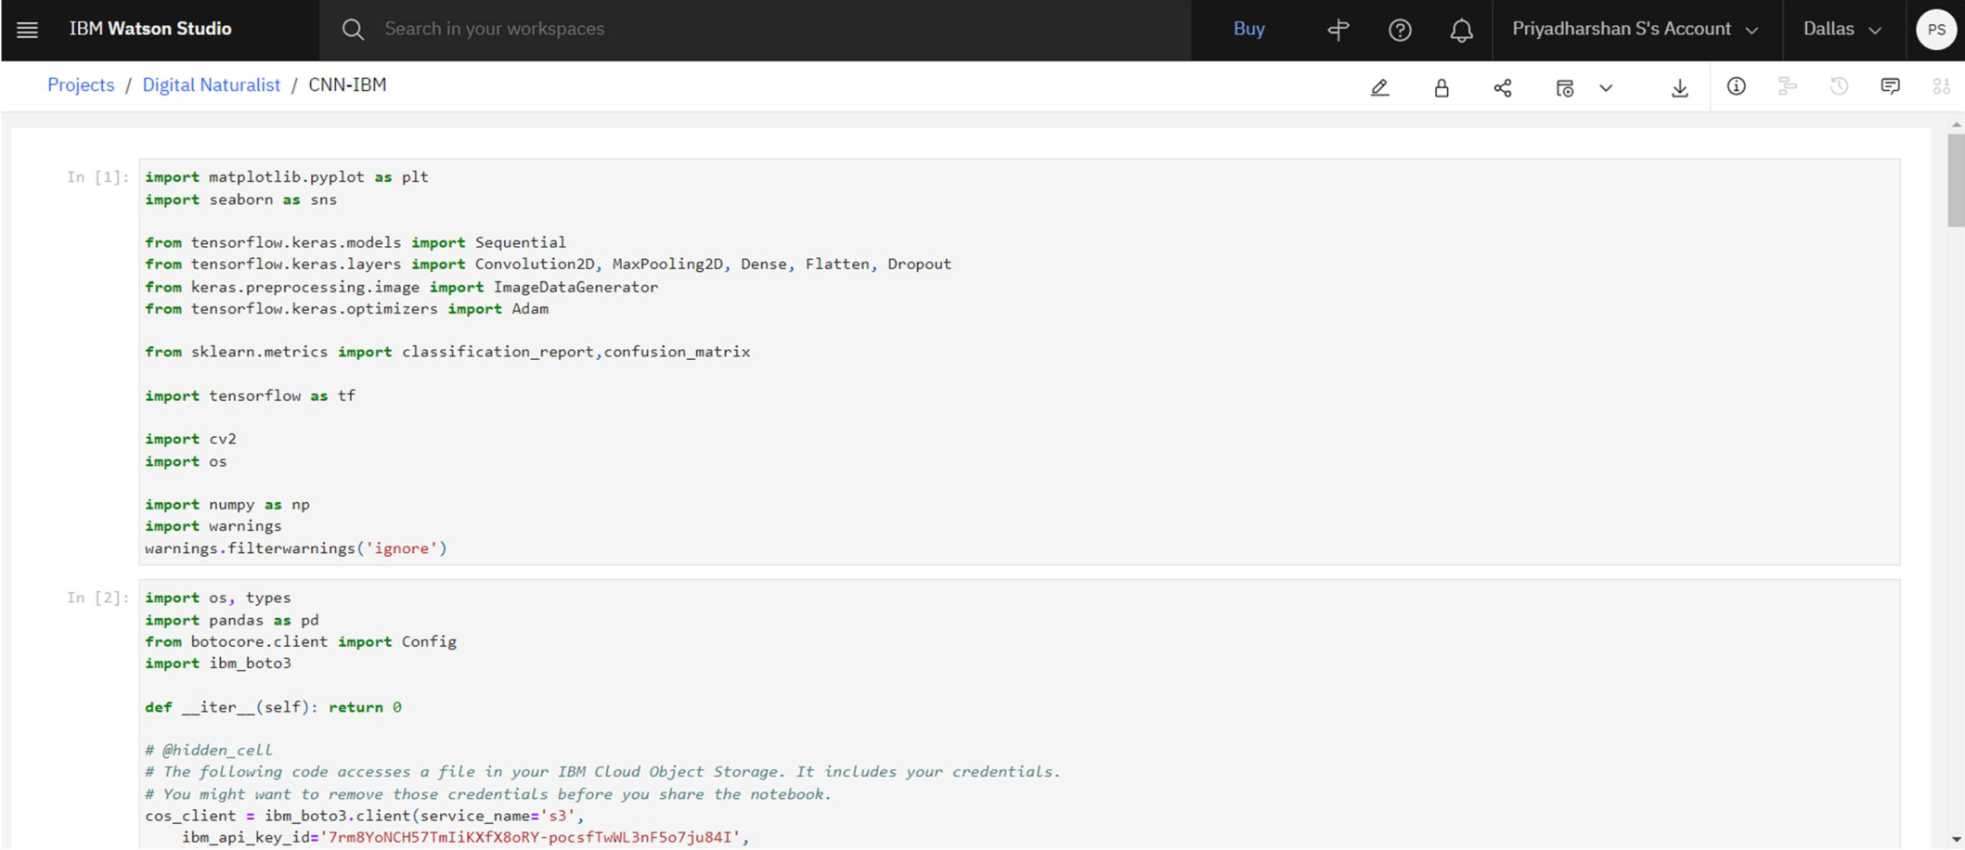

Sprint - I Milestones:

1. 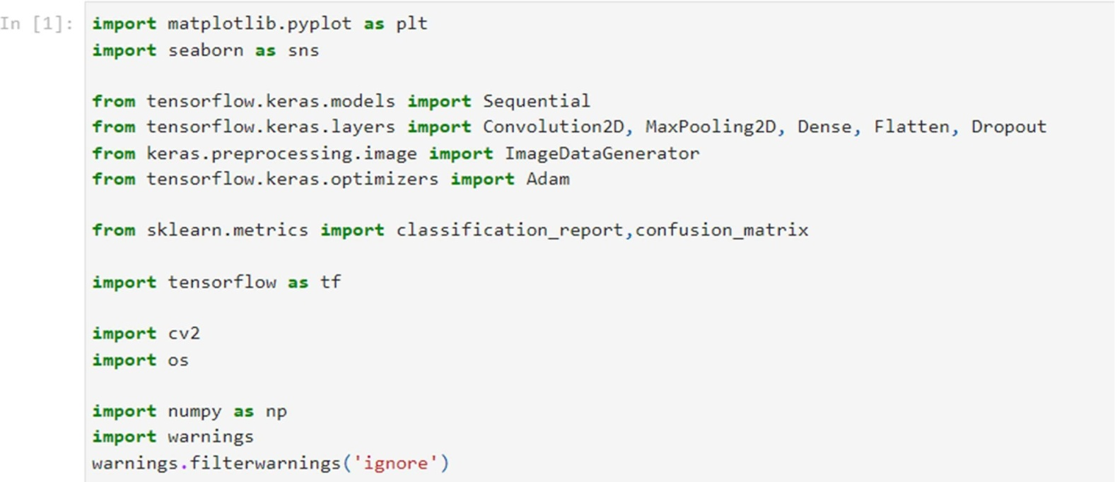**Import the Necessary Libraries**
2. **Upload and Connect Dataset with notebook**

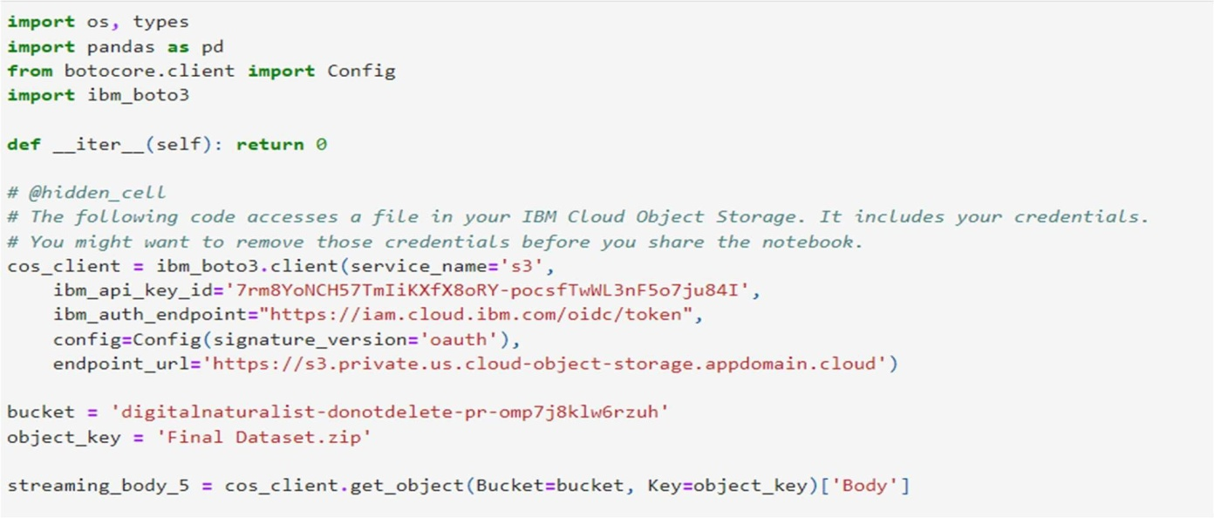

1. **Extracting the Dataset using BytesIO unzip function**

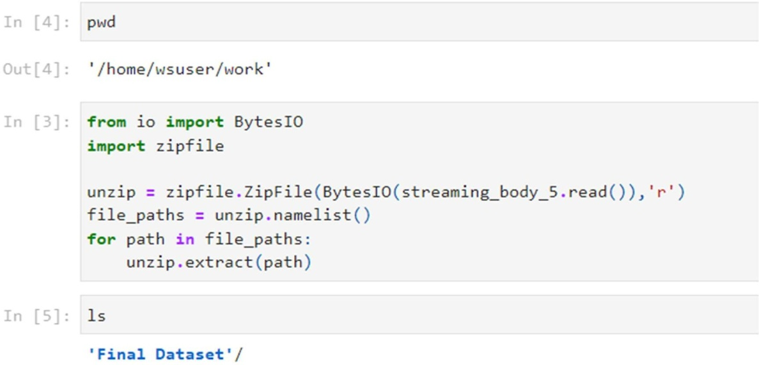

1. **The dataset directory is divided into training, testing and validation folders**

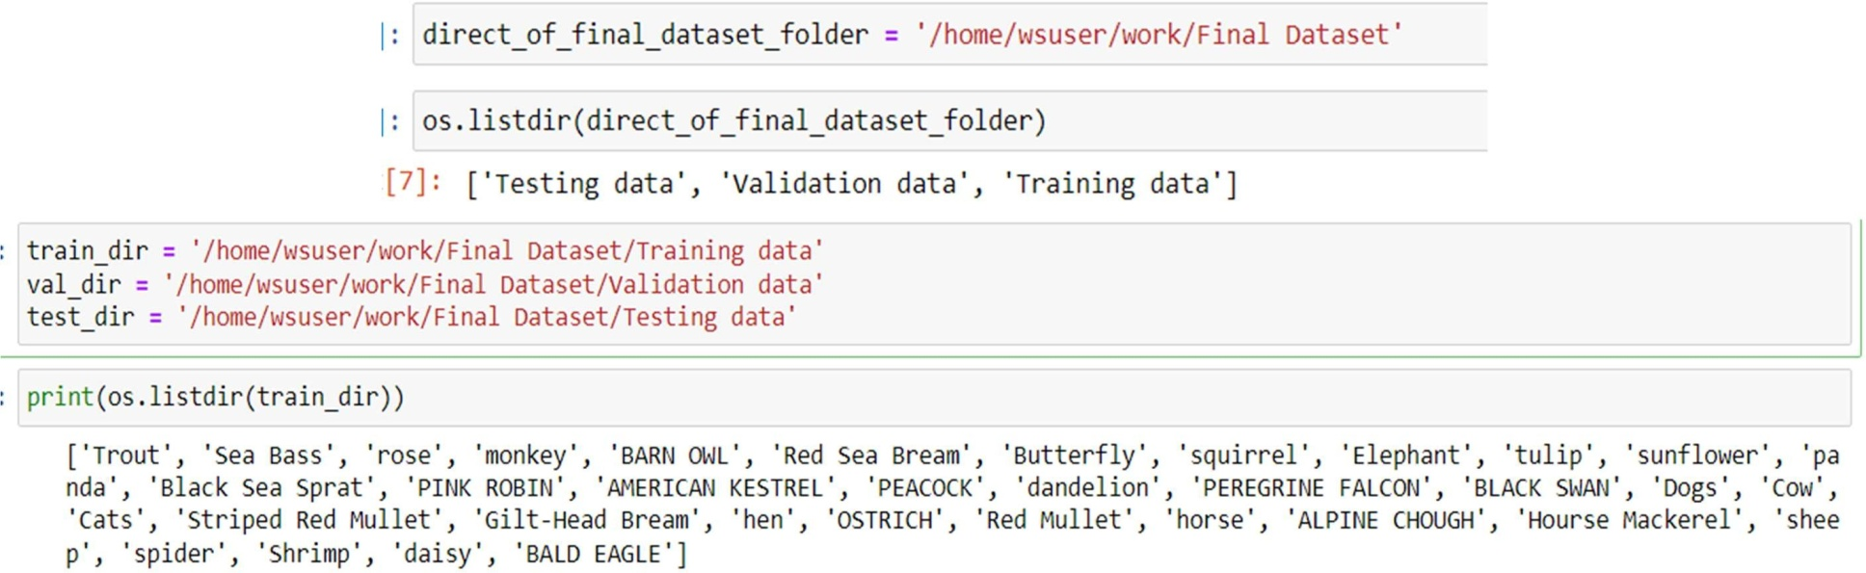

1. **Configuring ImageDataGenerator Class**

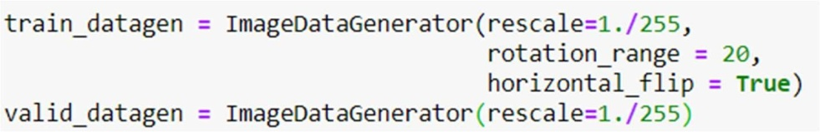

1. **Training, Testing and Validation Split-up**

70% data is split to Training data, 20% data is split to Validation data, 10% data is split to Testing data. Each dataset contain 35 classes. And in each class the Training dataset consist of 150 images, Validation dataset consists of 30 images and the Test dataset consists of 15 images.

1. **Apply ImageDataGenerator Functionality to train set and validation set**

